EXPERIMENT 05

Purpose of the Activity
This practical develops different views of the sales data already organized in the star-schema model. Transaction details are presented through a relational table, while grouped values are explored through a geographic hierarchy. Charts and an interactive dashboard are then used to compare performance and summarize important business measures.

Work to be completed
- Check the existing data model and geographic hierarchy.
- Prepare a detailed transaction report with sorting, filtering, and export.
- Summarize sales, profit, and quantity through a matrix.
- Compare category, region, customer, and yearly performance.
- Assemble a dashboard with KPI cards and interactive slicers.

AIM
To produce relational and multidimensional reports from the existing star schema in Power BI, and present the findings through comparative visuals and an interactive dashboard.

Learning objectives
- Confirm that the fact table is correctly connected to the customer, product, region, and date dimensions.
- Use transaction fields to inspect individual sales records.
- Apply a Region–State–City hierarchy to explore aggregated measures.
- Compare business performance with charts and interactive filters.

Required software and project files
- Microsoft Power BI Desktop.
- The .pbix project saved after Experiment 4.
- The model should contain Fact_Sales, Dim_Customer, Dim_Product, Dim_Region, and Dim_Date.
- Dim_Region should include the Geo_Hierarchy levels: Region, State, and City.

Model verification workflow
STAGE A | Load the previous project
Open Power BI Desktop and load the .pbix file from Experiment 4. Allow the report pages and model to finish loading.
STAGE B | Inspect table connections
Open Model view. Check that Fact_Sales is linked to Dim_Customer, Dim_Product, Dim_Region, and Dim_Date. The expected fact-to-dimension relationship is many-to-one (*:1), with active relationships.
STAGE C | Check the geographic levels
Select Dim_Region and confirm that Geo_Hierarchy is arranged as Region, then State, then City. Reuse the existing hierarchy rather than creating a duplicate.
STAGE D | Review earlier report pages
Return to Report view and open the Slice, Dice, and Drill pages from the earlier experiment. Make sure their visuals show values and do not display errors or blank results.
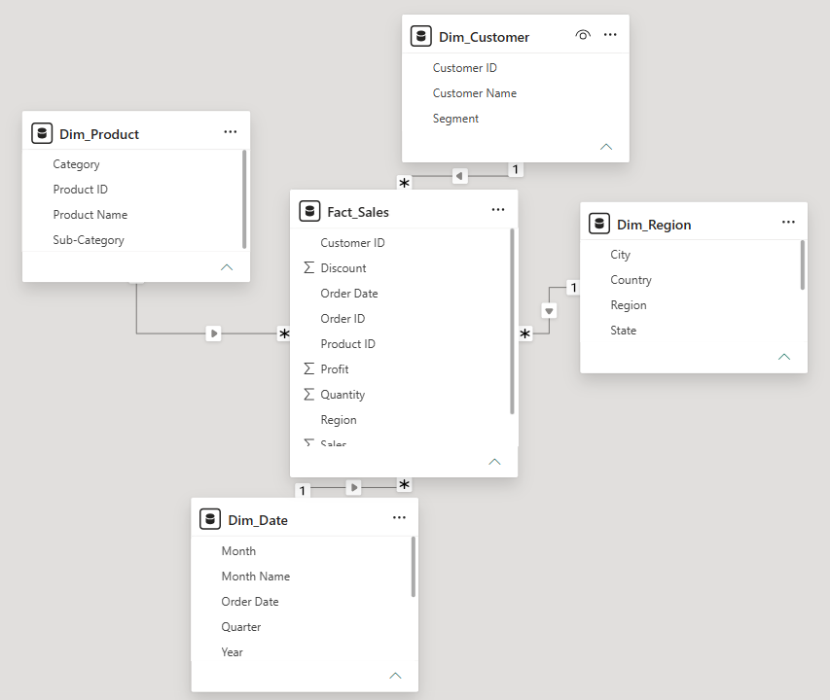

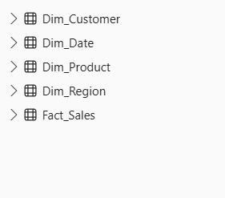

02 / TRANSACTION VIEW

Prepare the Relational Sales Report
A relational report keeps individual records visible. It is useful when a user needs to inspect a particular order, customer, product, or profit value.

Report construction
STAGE 1 | Create a dedicated page
Use the plus (+) control to insert a report page. Rename the page as Relational Report.
STAGE 2 | Place a Table visual
Choose the Table visual from the Visualizations pane. Resize it so the required columns can be read without excessive scrolling.
STAGE 3 | Populate the table
Add the following fields in the stated sequence: Order ID from Fact_Sales, Customer Name from Dim_Customer, Product Name from Dim_Product, Region from Dim_Region, Sales from Fact_Sales, and Profit from Fact_Sales.
STAGE 4 | Arrange records by sales
Select the Sales column heading and sort the values in descending order. If the first selection gives ascending order, select it again.
STAGE 5 | Restrict the displayed records
In the Filters pane, add a visual-level filter for Profit. Set the condition to greater than 0 and apply it. Check that the remaining rows have positive profit.
STAGE 6 | Export the displayed information
Open the menu for the table visual and choose Export data. Save the file in one of the formats offered by Power BI, such as Excel or CSV. Open it if you need to verify the exported rows.
STAGE 7 | Capture report observations
Record the number of rows left after filtering. Also note the customer and product appearing at the top of the sales-sorted table. Use the values displayed in your own report.
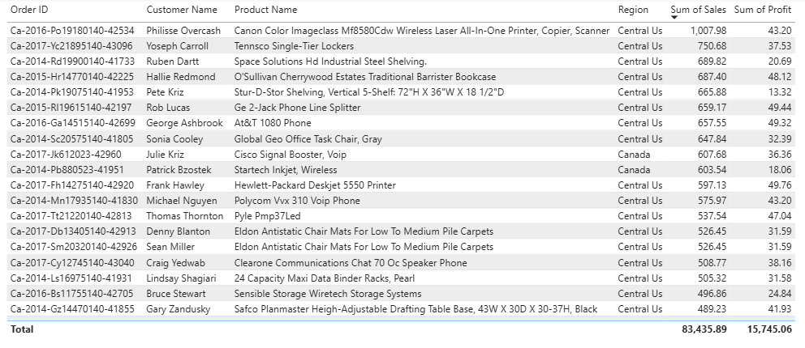

03 / SUMMARY VIEW

Explore Data with a Geographic Matrix
The matrix groups records instead of listing each transaction separately. Its hierarchy makes it possible to move between regional, state, and city summaries.

Matrix setup and exploration
STAGE 8 | Add the matrix page
Create another report page and give it the name Matrix Report.
STAGE 9 | Insert the Matrix visual
Select Matrix in the Visualizations pane and adjust its size to use the available report area.
STAGE 10 | Set the row hierarchy
Drag Geo_Hierarchy from Dim_Region into the Rows section of the matrix. Confirm that the hierarchy contains Region, State, and City in that order.
STAGE 11 | Add numerical measures
Place Total Sales, Total Profit, and Quantity in the Values section. Use the measures already present in the model. If Quantity is added as a column, check its summarization and select Sum where appropriate.
STAGE 12 | Explore lower levels
Use the matrix drill or expand controls to move from Region to State and then to City. Observe how the sales, profit, and quantity totals are divided at each level.
STAGE 13 | Return to higher levels
Use the drill-up control or collapse the hierarchy to move back from City to State and Region.
STAGE 14 | Cross-check earlier results
Choose the same state that was examined on the Drill page in Experiment 4. Compare its city-level values with the Matrix Report, keeping the filters and aggregation level consistent.

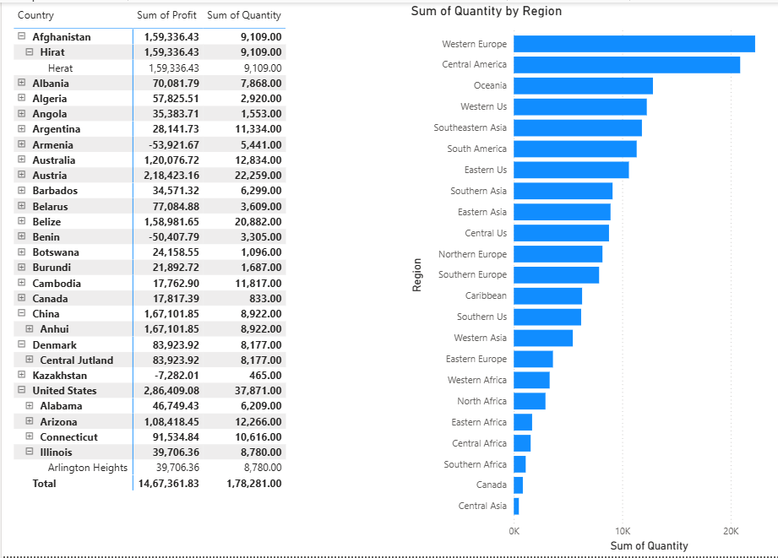

Expected interpretation
The matrix should show aggregated values at each geographic level. Drilling down provides more detail, while drilling up restores the broader summary. Differences in filters or aggregation levels can affect the comparison, so use matching selections when checking the earlier report.
/ VISUAL COMPARISON

Build the Comparative Analysis Page
Charts help reveal differences and trends that may not be obvious from a long transaction table.

Visuals to include
STAGE 15 | Open a fresh analysis page
Add a report page and name it Comparative Analysis.
STAGE 16 | Show sales by category
Copy the category sales chart from Experiment 3 or recreate it. Confirm that Category is used for the category comparison and the sales measure is used as the value.
STAGE 17 | Show profit by region
Add or copy the regional profit chart. Check that Region is the comparison field and Total Profit is used as the measure.
STAGE 18 | Rank the leading customers
Insert a bar chart. Put Customer Name on the Axis and Total Sales (or Sales summarized as Sum) in Values. In the visual-level filter for Customer Name, select Top N, enter 10, set Total Sales as the By value, and apply the filter.
STAGE 19 | Display the yearly sales pattern
Insert a line chart. Place Year from Dim_Date on the X-axis and Total Sales in Values. Check that the years appear in chronological order and that sales are aggregated correctly.
STAGE 20 | Format and position the charts
Use these titles: Sales by Category, Profit by Region, Top 10 Customers by Sales, and Sales Trend by Year. Arrange the four visuals so that labels and values remain readable.

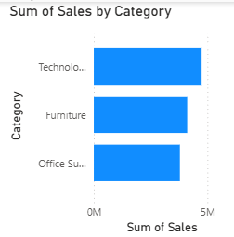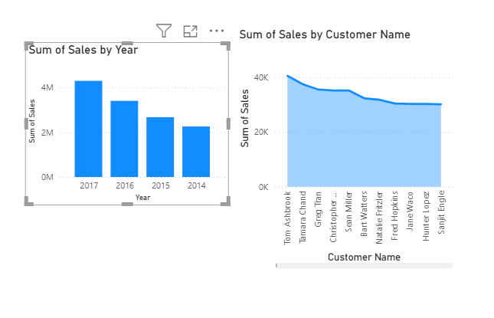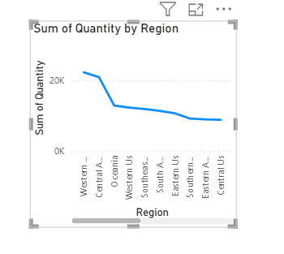

Analysis notes
Compare the chart patterns with the Relational Report. Identify the categories and regions that stand out, the customers included in the top ten, and the direction of sales across years. Write observations only after checking the actual chart values.
05 / INTERACTIVE SUMMARY

Assemble the Dashboard
The dashboard brings the most useful measures and visual comparisons together. Slicers allow the displayed information to be examined for selected regions, product categories, and years.

Dashboard configuration
STAGE 21 | Create the dashboard canvas
Add a new report page and name it Dashboard. Keep enough space between elements so that the cards, charts, and slicers can be read clearly.
STAGE 22 | Place KPI cards
Insert Card visuals for Total Sales, Total Profit, and Total Orders. Select the corresponding measures already available in the model. If Total Orders is not present, use the appropriate order-count measure or create it according to the lab model instructions.
STAGE 23 | Bring in the main charts
Copy or add suitable visuals from Comparative Analysis. Include the key sales and profit patterns alongside the KPI cards.
STAGE 24 | Add the dashboard filters
Create three slicers: Region from Dim_Region, Category from Dim_Product, and Year from Dim_Date.
STAGE 25 | Test the filter behaviour
Select one value in each slicer separately. Observe whether the KPI cards and charts update. If a visual does not respond, open Format > Edit interactions and check that filtering is enabled for it.
STAGE 26 | Restore the default view and save
Clear the slicer selections to return to the unfiltered dashboard. Save the .pbix project and confirm that the Dashboard page is still available.

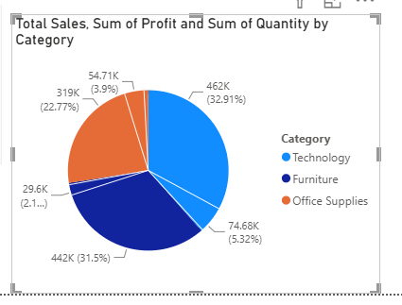
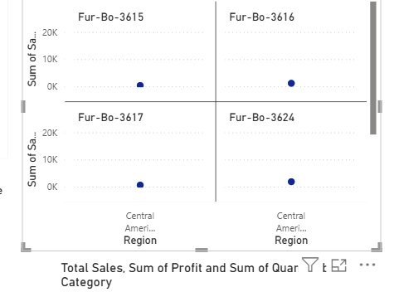
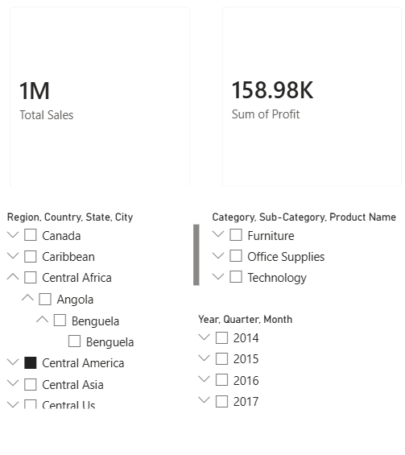

Dashboard checklist
- Three KPI cards are visible: Total Sales, Total Profit, and Total Orders.
- The dashboard includes relevant charts from the comparative analysis.
- Region, Category, and Year slicers are present.
- Changing a slicer updates the applicable cards and visuals.
- The saved project opens with the Dashboard page available.

06 / FINDINGS

Result
The relational report, geographic matrix, comparative charts, and interactive dashboard were prepared using the existing Power BI star-schema model. The table supports transaction-level checking through sorting, filtering, and export. The matrix summarizes measures across the geographic hierarchy, while the charts and dashboard support comparison and interactive review. The practical is complete after the actual observations have been entered and the report has been saved.

Learning outcomes
- Prepared a relational report using transaction-level information (CO3, BT3).
- Created a multidimensional report using the existing hierarchy and star schema (CO3, BT3).
- Applied sorting, filtering, aggregation, and drill operations to sales data (CO3, BT3).
- Designed an interactive dashboard using KPI cards and slicers (CO3, BT3).
- Interpreted findings across relational, matrix, and visual reports (CO3, BT4).

Final submission check
- Relational Report page completed and exported data checked.
- Matrix Report page completed and hierarchy tested.
- Comparative Analysis page contains all four charts.
- Dashboard page contains the three KPI cards and three slicers.
- Actual observations entered and the final .pbix file saved.

